MEDZAH Medical Product & Administration Management System
Product Management | Order Management | Reporting | User Roles | Permissions | Messaging

Project Overview
MEDZAH is a web based administration platform built for managing medical products, orders, users, reports, permissions, and internal communication from one centralized system.
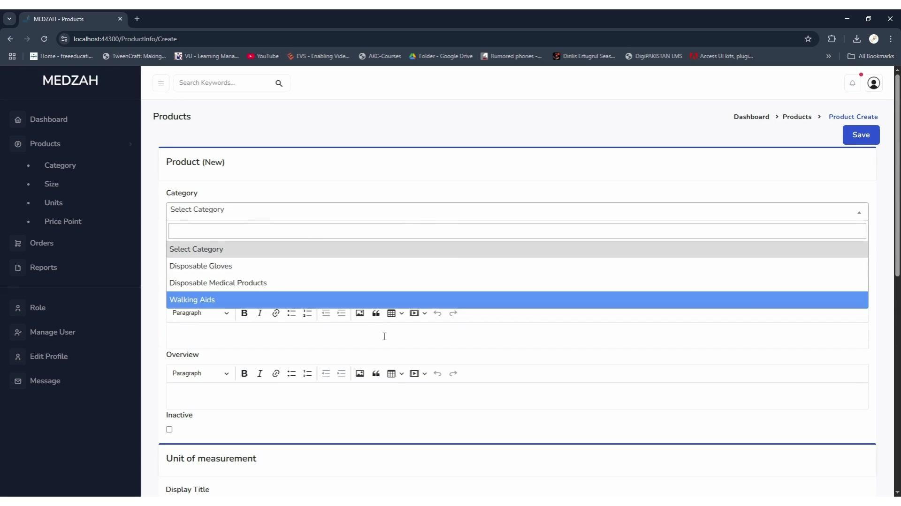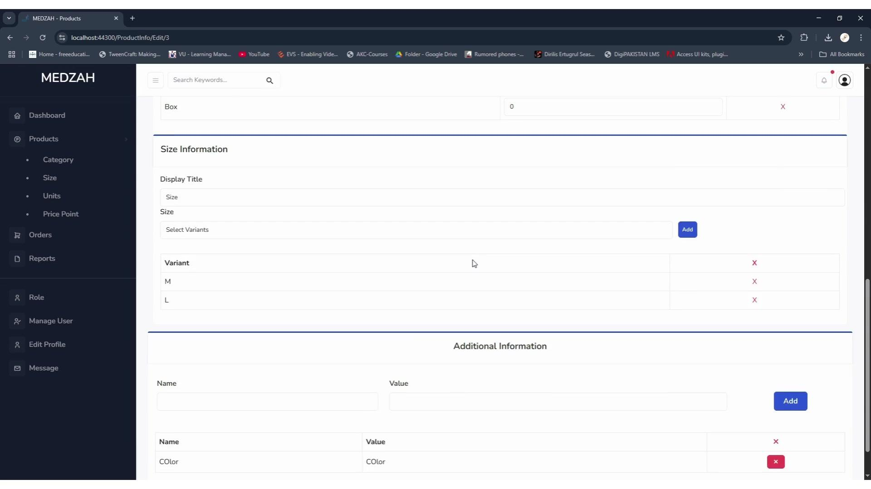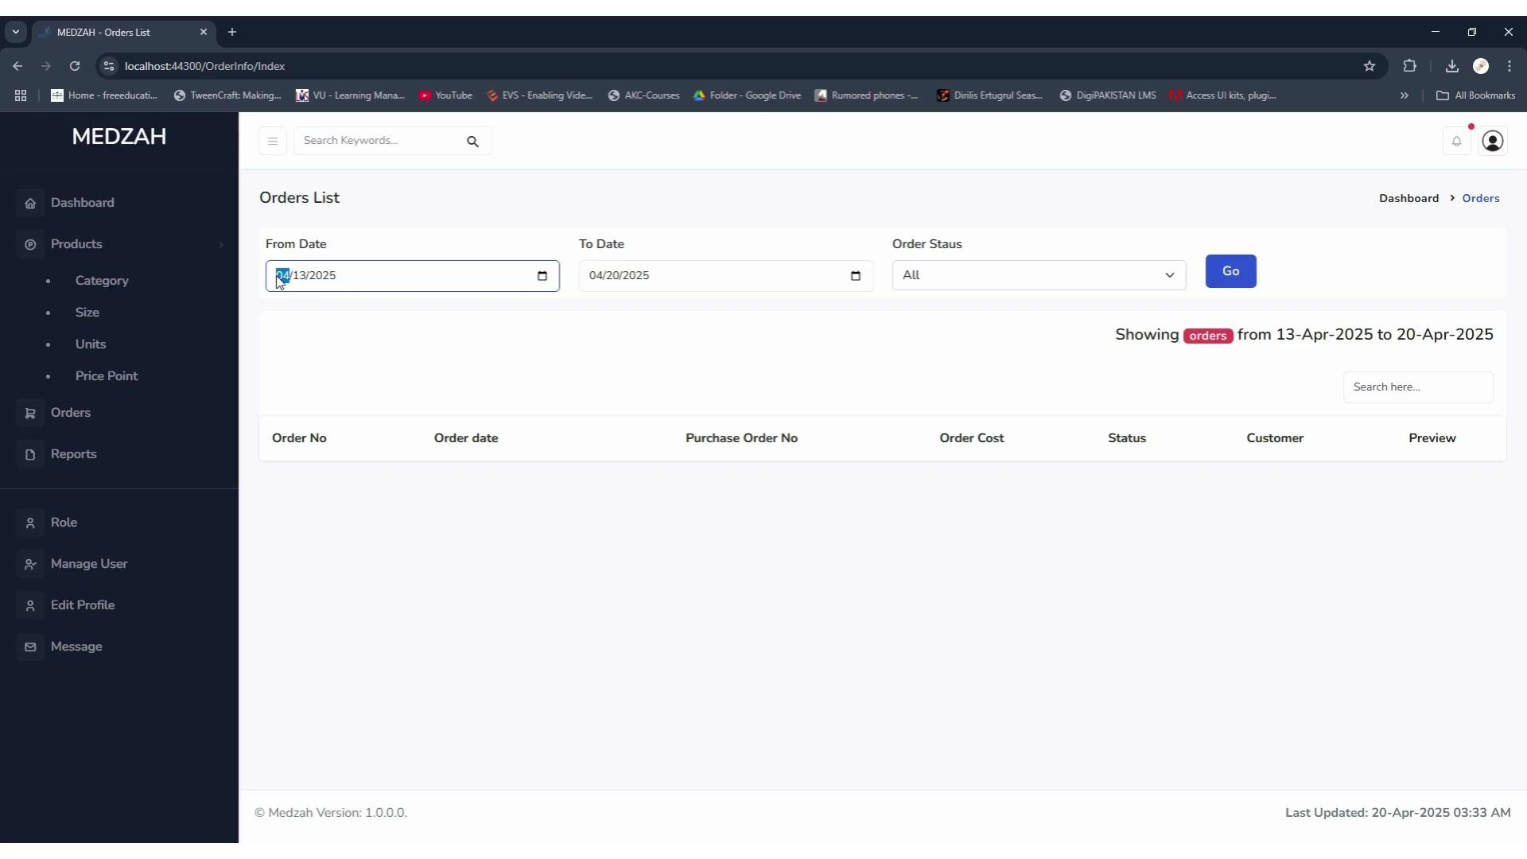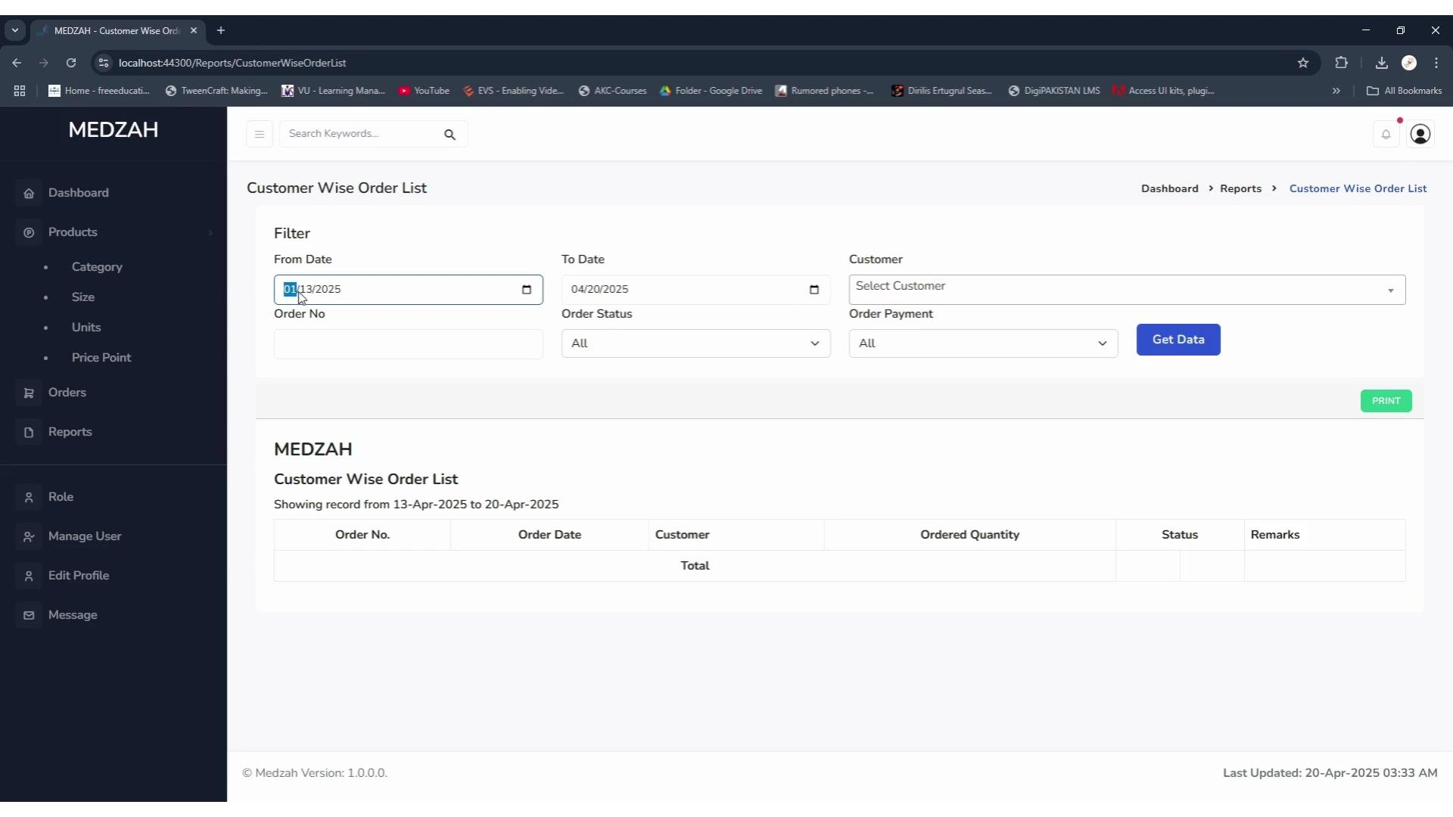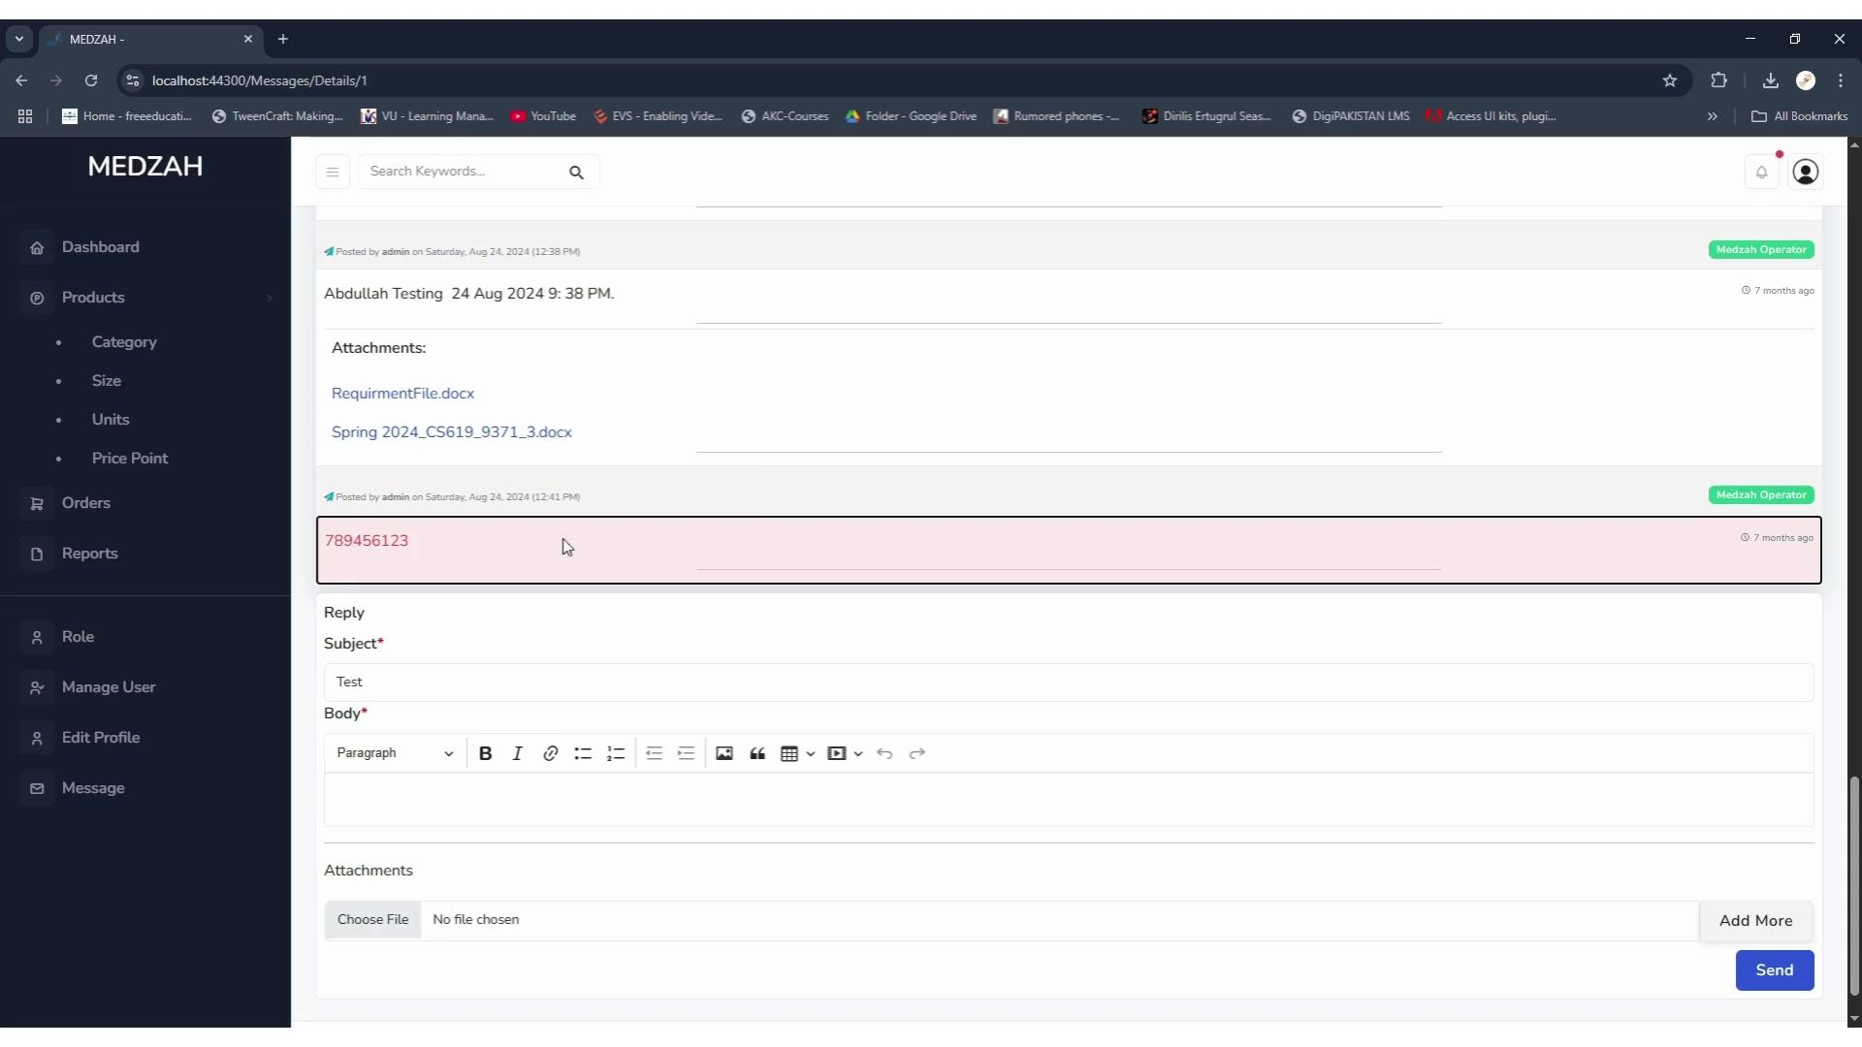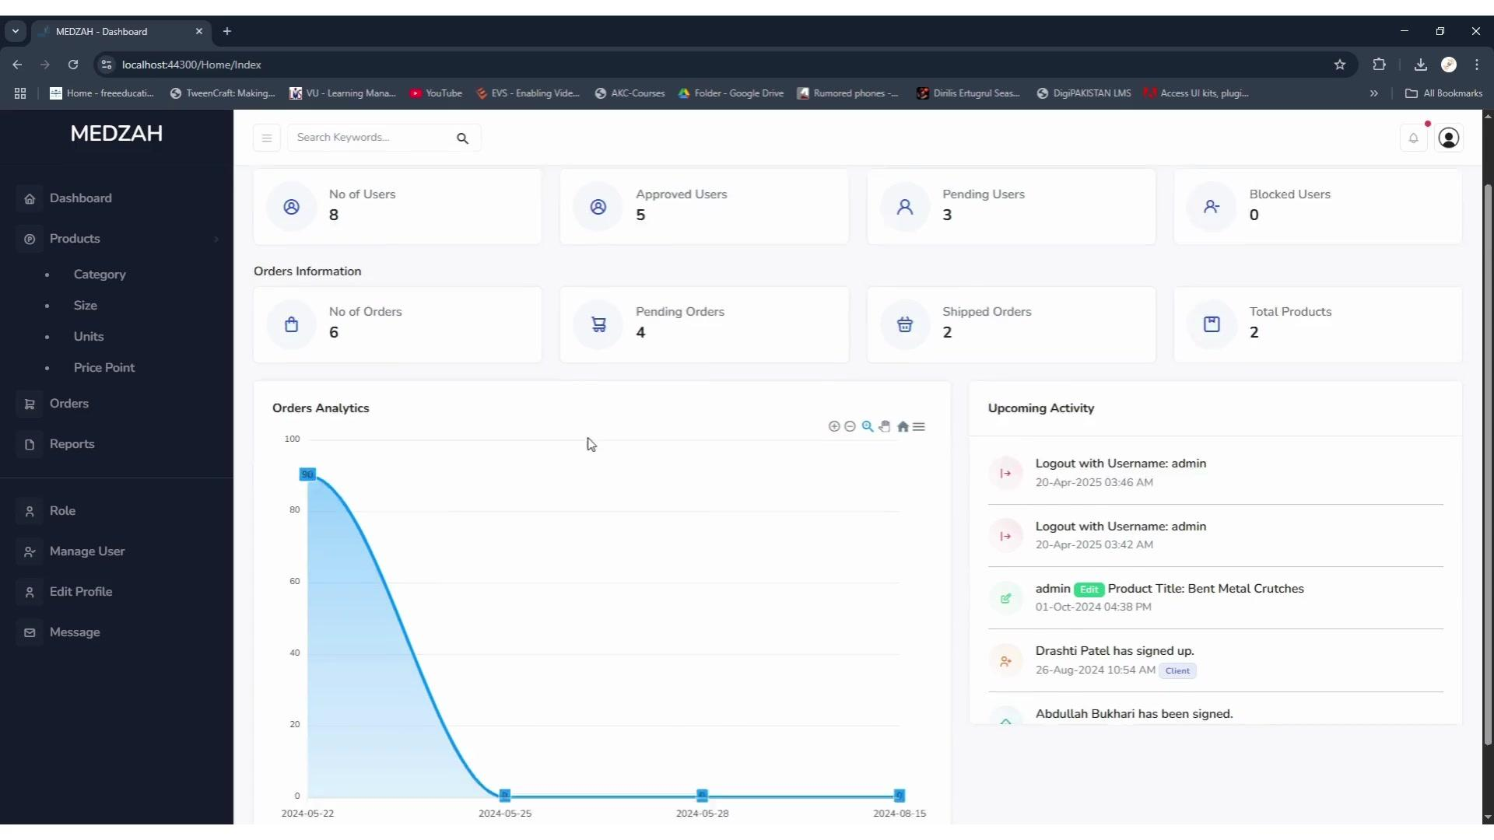

Main Modules
• Dashboard
• Products
• Categories
• Sizes
• Units
• Price Points
• Orders
• Reports
• Roles
• Manage Users
• Edit Profile
• Messaging

Dashboard
The dashboard gives administrators a quick view of business activity:
• Total users
• Approved users
• Pending users
• Blocked users
• Total orders
• Pending orders
• Shipped orders
• Total products
• Order analytics
• Recent system activity

Product Management
Administrators can create and manage medical products with:
• Product categories
• Product descriptions and overview
• Active or inactive status
• Units of measurement
• Product sizes
• Product variants
• Additional product attributes
• Rich text content
The product structure allows different sizes, units, and specifications to be maintained for individual products.

Order Management
The Orders module provides a centralized view of customer orders with:
• Order number
• Order date
• Purchase order number
• Customer
• Order cost
• Order status
• Search
• Date filtering
• Status filtering
• Order preview

Reporting
The system includes Customer Wise Order List reporting with filters for:
• Date range
• Customer
• Order number
• Order status
• Payment status
Reports can be generated and printed for administrative use.

Role & Permission Management
The platform includes detailed role based access control.
Administrators can control permissions for individual modules and actions such as:
• View
• New
• Edit
• Delete
• Report access
This allows different users to receive access according to their responsibilities.

User Management
Administrators can monitor and manage user accounts based on their status:
• Approved
• Pending
• Blocked
The system also provides user administration and profile management.

Messaging
An integrated messaging module allows users and operators to communicate within the platform.
• Message history
• Replies
• Rich text messages
• File attachments
• Multiple attachments
• Subject and message content

Activity Monitoring
The dashboard includes an activity section showing events such as user registrations, administrator activity, product updates, and other system actions.

Result
MEDZAH brings medical product management, customer orders, reporting, user administration, permissions, analytics, and communication into one organized platform.
The result is a centralized administration system that gives the business better control over its products, orders, users, and day to day operations.

